Feedback form



Non-statutory consultation

**Deadline for feedback: Sunday 13 April 2025**

**Our non-statutory consultation**

Ossian is a proposed floating offshore wind farm located approximately 80km off the east coast of Scotland (referred to as the Ossian Array). It has the potential to deliver up to

3.6GW of renewable energy and, once built, will connect to the grid via the connection points National Grid have offered - at proposed substations near Spalding and Alford in Lincolnshire.

These proposals, referred to as the Ossian Transmission Infrastructure, include all the elements needed to connect the Ossian Array to the national grid in Lincolnshire.

Those elements are -

* Offshore export cables
* a Landfall location on the Lincolnshire coast
* Onshore export cables
* Onshore converter stations close to proposed National Grid substations.

Ossian has the capability of powering up to 6 million homes annually and offsetting up to 7.5 million tonnes of carbon emissions each year. This makes it vitally important in supporting the UK’s target of reaching net zero by 2050.

Please note that this form is unable to address concerns or queries relating to any other proposed developments other than Ossian.

**Please complete this form and return by 11.59pm on Sunday 13 April 2025.**

**At an event:** please **hand your completed feedback form to a member of the Ossian team**, or **leave it in the feedback box provided.**

**By post: Freepost Ossian Transmission**. It’s free and you don’t need a stamp.

**By Email:** Complete the form, scan it and email to [**info@ossiantransmission.com**](mailto:info@ossiantransmission.com)

***Name:***

***Telephone number:***

***Email address:***

***Postal address:***

***Do you represent an organisation? (Yes / No) If yes, which one?***

***Where did you hear about this consultation (tick all that apply)?***

Poster

◻

Newspaper advert Online advert Postcard through door

◻

◻

◻

# Climate change

Email

Word of mouth Other

◻

◻

◻

In general, what is your attitude towards climate change? (select most appropriate) Climate Change is the most important issue we face that must be addressed

◻

Climate Change is real, however there are other priorities that we must focus on currently

◻

◻

Climate Change is not a threat and supposed impacts are being over-stated

# Climate change and role of offshore wind

In general, what is your attitude towards offshore wind projects (tick all that apply)

Offshore wind will play a crucial role in addressing the worst impacts of Climate Change

◻

◻

◻

Offshore wind can bring a host of economic benefits to the UK and should be delivered.

Offshore wind is part of the solution, but other sources of energy are also required.

Offshore wind has no significant role to play in the future of UK energy

◻

Any information given on this form can be used and published anonymously as part of our consultation reporting. We will always treat your data with respect, keep it secure, and never sell it to third parties or use it for purposes other than considering it to inform the development of the Ossian Wind Farm. Our privacy notice is available to view at [www.ossianwindfarm.com/privacy-notice](http://www.ossianwindfarm.com/privacy-notice)

Offshore cables will run from the wind farm to shore at a location known as ‘Landfall’.

A preferred Landfall area of search has been identified, within which the proposed Landfall would be located. This area includes the part of the coastline between the southern edge of Sandilands and Anderby Creek. We are aware of sensitive habitats and seeking to mitigate impacts where possible.

380000

***Looking at the Landfall area of search we’ve identified during this consultation, do you have any comments that would help us develop our proposals?***

375000

377500

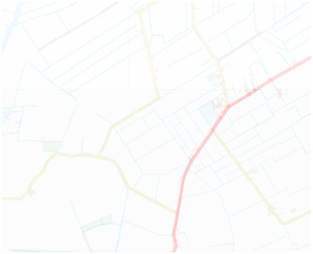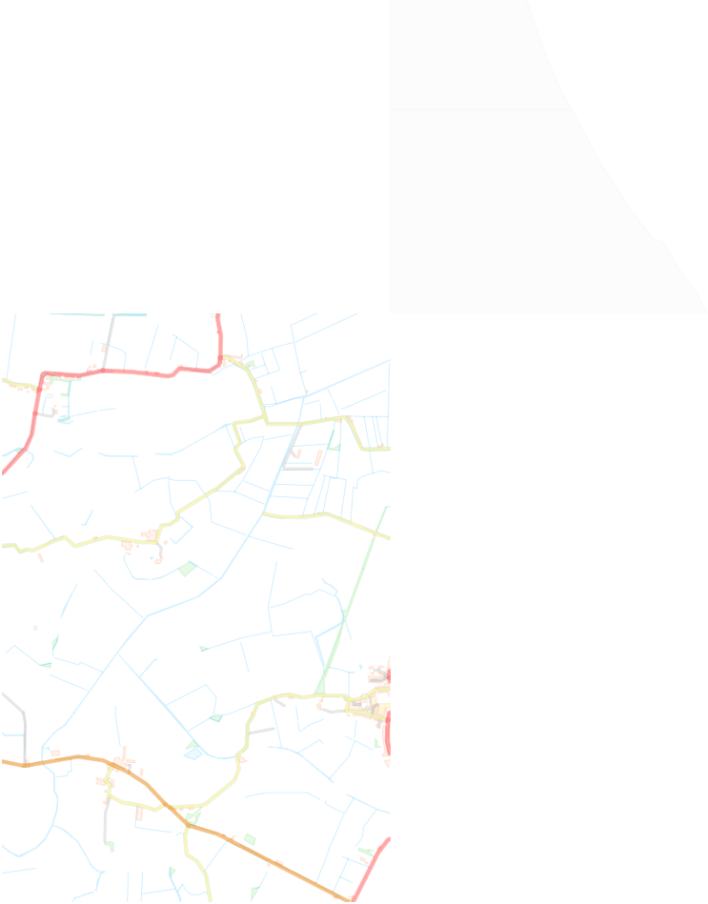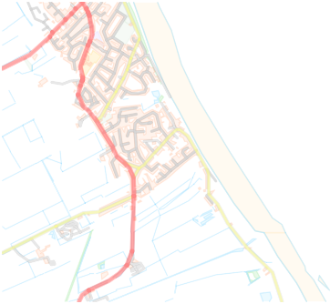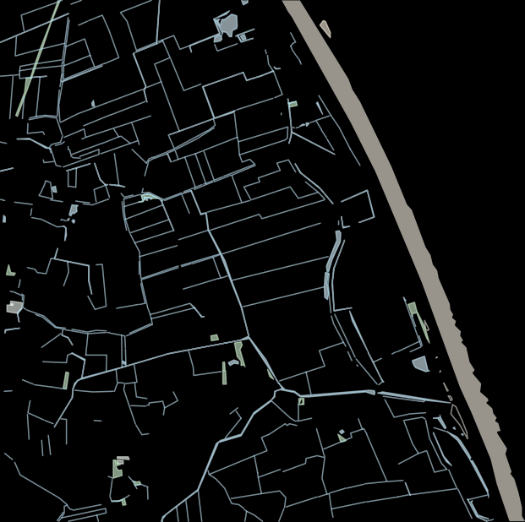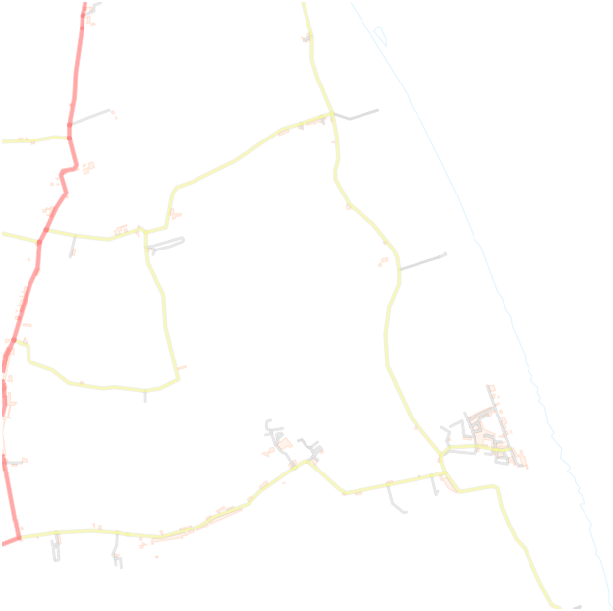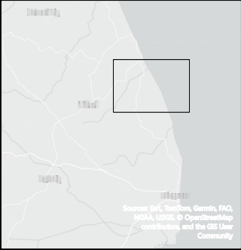

**Legend**

Landfall Area

±

550000

552500

555000

557500

Sources: Esri, TomTom, Garmin, FAO, NOAA, USGS, © OpenStreetMap contributors, and the GIS User

Community

Contains OS data © Crown Copyright and database right 2023

Contains data from OS Zoomstack

1:25,000 0

1.25

2.5

5 km

Preferred Landfall Search Area

The onshore cable corridor will be located within the Onshore Transmission Infrastructure Study Area and will run from the Landfall to the onshore converter stations and on to the proposed National Grid substations. Onshore export cables will be installed underground along this corridor.

As we continue to refine our proposals, we will look to establish preferred cable corridor options and present this refinement as part of the next stage of our public consultation at the end of the year.

***Do you have any comments on the area that will help us to identify preferred cable corridor options?***

As part of the Ossian Transmission Infrastructure, new onshore converter Stations are required to transform the electricity supplied by the Ossian Array from HVDC to HVAC before it can be fed into the national grid network.

S

ea Lane

R

oman

Ban

k

Sutton

Ro

a

d

ree

ld

ee

d

G

l

Ry

n

fi

e

gh

u

Ha

Rom

e

d

n

Ings Roa

La

a

n

Bank

380000

*r*

*e t*

*G*

*a u*

*a*

*E*

Alf

ord

n

R

e

La

M

oad

rabtree La

nf

C

La

e

i

n

n

e

Mill La

e

ne

La

G

n

r

e

e

This could include:

* one converter station close to National Grid’s proposed Lincolnshire Connection Substation A; and

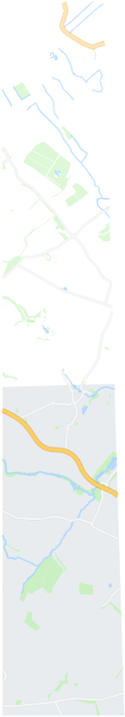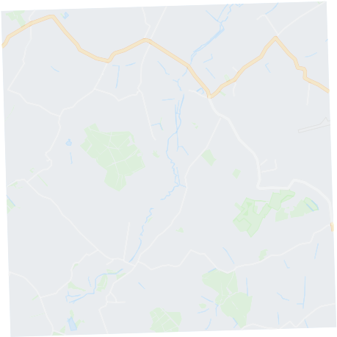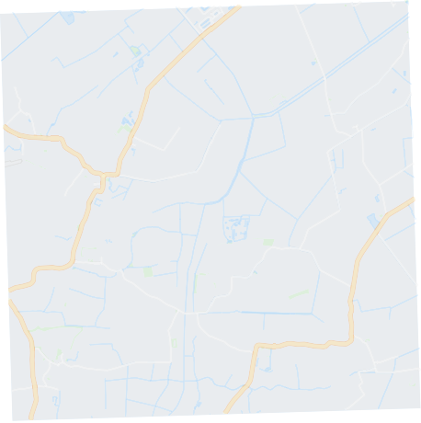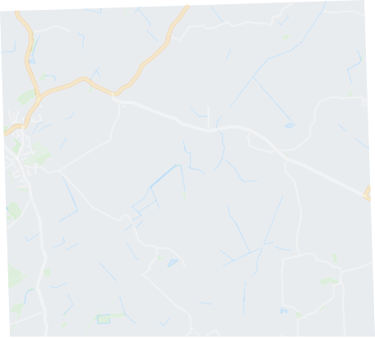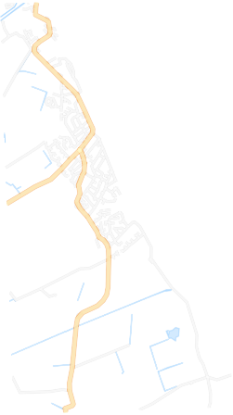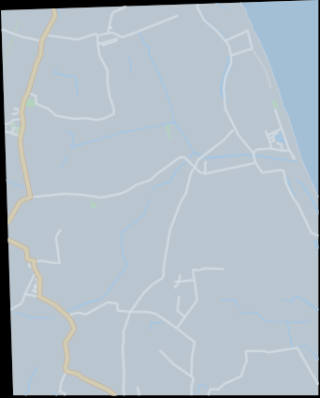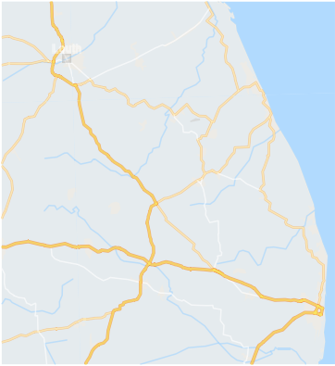

**Legend**

LSC A Area Of Search ±

540000

545000

550000

555000

**GAYTON LE MARSH**

**MABLETHORPE**

*Springwell Alternative Academy*

A157

A157

**STRUBBY**

**WITHERN**

**MALTBY LE MARSH**

*Strubby Airfield*

**TON**

A52

A1104

**BEESBY**

*Woodthorpe Hall Golf Club*

**CLAYTHORPE**

**HANNAH**

**MARKBY**

**BELLEAU**

**ABY**

Louth

Grimoldby

**SWABY**

A157

**SOUTH THORESBY**

A157

A16

A1104

A1111

A16

Alford

B1449

**HAUGH**

**ALFORD**

A52

**RIGSBY**

astle

A1028

A16

Spilsby

A1104

B1183

**FARLESTHORPE**

**WELL**

B1196

**CUMB**

Skegnes

Sources: Esri, TomTom, Garmin, FAO, NOAA, USGS, © OpenStreetMap contributors, and the GIS User

Community

**L**

A16

Sources: Esri, TomTom, Garmin, FAO, NOAA, USGS, © OpenStreetMap contributors, and the GIS User Community

1:45,000 0

1.25

2.5

5 km

A16

A1028

Onshore Converter Station Area of Search - LSC A

e

n

a

s

n

et

West Bank

P

a

er'

New L

L

e

Mile L

a

n

e

385000

et

d

a

Ro

in La

A

lf

a

ord Road

orth

N

St

ain Stre

***Do you have any comments on our proposals above to construct new converter stations that will help us to refine our plans?***

ne

**ERWORTH**

**HUTTOFT**

**ANDERBY**

**MUMBY**

Long La

Ings La

375000

As part of the Ossian Transmission Infrastructure, new onshore converter stations are required to transform the electricity supplied by the Ossian Array from HVDC to HVAC before it can be fed into the national grid network.

sh

R

o

ad

R

oad

l

d

d

w

W

a

oa

F

oa

te

ashway R

ip

P

d

ton

B

os oa

hway

Road

os

R

C

r

s

L

a

ane

eet

o d

Sluice

Carrington

Road

R

l

tf

G

l

a

S

ate

Mi

ddle

325000

330000

Common Road

oad

M

tock

sh R

ar

Mars

w

S

h R

ar

e

M

ate

Eastern

H

n

G

oad

l

ell

al

o

La

o

ur

B

a

o

R

an

u

n R ad

H

an

Rom

Gate

se

n

Gat

Woodh

k

d

e

Stockwel

ad

S

R

o

l

l

t

l

tio

a

R

R

e

G

This could include:

* up to two converter stations close to National Grid’s proposed Weston Marsh Substation.

Gr

e

Spa

ldi

R

o

ad

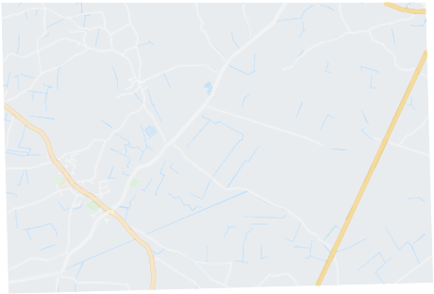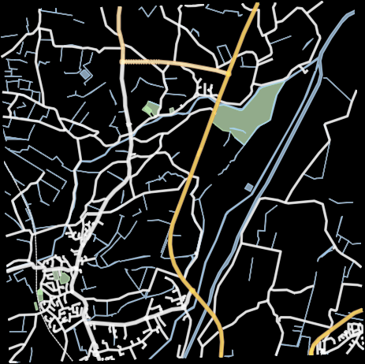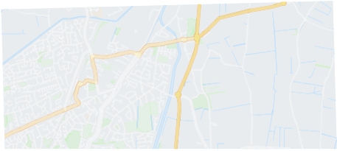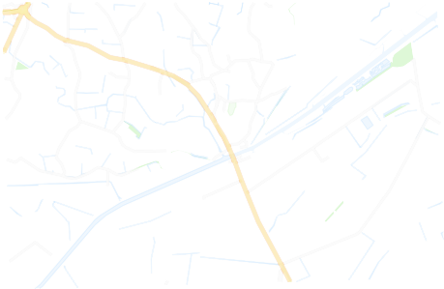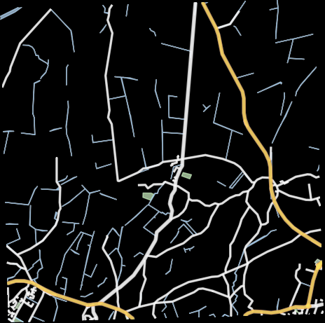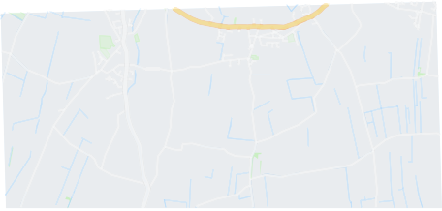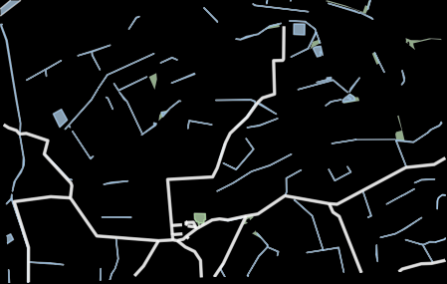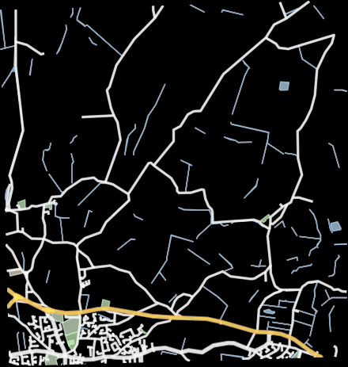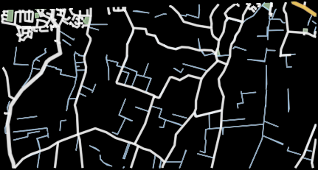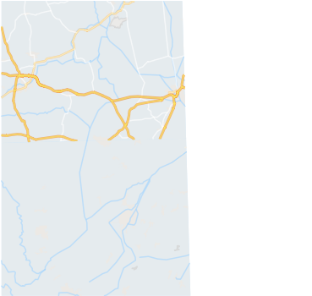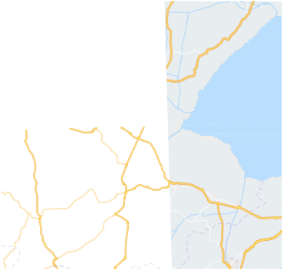

**Legend**

WM Area Of Search

±

**SPALDING**

525000

530000

535000

540000

Lincolnshire

Billinghay

A16

B1183

A52

Sibsey

B1397

**NG**

A17

Sleaford

Heckington

BostonButterwick

**FOSDYKE**

A16

**GOSBERTON**

A52

Billingborough

Holbeach

Spalding

Long Sutton

B1397

Bourne

A152

A16

Crowland

Sources: Esri, TomTom, Garmin, FAO, NOAA, USGS, © OpenStreetMap contributors, and the GIS User

WalCs oomk emnunity

*Spalding Golf Club*

**SURFLEET**

A17

B1357

B1356

A16

B1180

A17

**WESTON**

B1356

A16

eet

A151

**HOLBEACH**

A151

A17

A151

**MOULTON**

igh

**WHAPLODE**

**GED**

**FLEET**

B1356

B1357

B1168

Sources: Esri, TomTom, Garmin, FAO, NOAA, USGS, © OpenStreetMap contributors, and the GIS User Community

1:45,000 0

1.25

2.5

5 km

Onshore Converter Station Area of Search - Weston Marsh

H

os

te

be

r

Cook's Road

G

n

Ga

k

rton Ba

k

e

M

ill L

Was

k

r

sh

ane

Ma

L

ne

a

g

e

n

ve

ed Cow Dro

ar

oad

a

ost

S

n R

o

B

Middle Marsh Road

e

h Gat

W

a

te

***Do you have any comments on our proposals above to construct new converter stations that will help us to refine our plans?***

e Ba

n

Lo

te

Ban

ll

k

Mi

a

Cla

p

G

t

on

er's D

G

Hall

t Gate

a

dl

Stron

ate

rove

Eas

G

in

t

Mill

Sw

e

ane

u

h

Gate

Ga

at

k

e

B

nch

ntsgate

te

ate

aisdike Lan

Dam

Be

ro

es L

Lan

Bra

te

G

d

ng e

E

a

st

a

n'

s Gate

in

a

r M

Snaffe

r's Lane

o

d

# Landowners/Occupiers

As we continue to refine our proposals, we will look to establish preferred landfall, underground cable corridor and onshore converter site options.

***What are the key concerns you as a landowner/ occupier have about the project and how do you think we can reasonably mitigate any impact on farming or other current use on the land?***

# Offshore Infrastructure

In addition to the onshore infrastructure we’re proposing in Lincolnshire, we’ll also need to install offshore export cables which will connect the offshore substation platforms, which are part of the Ossian Array, to the chosen landfall area on the Lincolnshire coast.

Offshore export cables are being proposed over approximately 500km. The cables would be installed between one and three meters below the surface of the seabed, with methods including trenching, ploughing, mass flow excavators and mechanical cutters currently being considered.

***Do you have any comments on the offshore cable route search area or our approach to offshore cable installation?***

As part of our project development, Ossian will engage with a range of marine users such as the fishing community, shipping industry, environmental agencies and other recreational users.

***Are there any specific marine user groups you feel Ossian should identify and engage with as part of their development of offshore infrastructure?***

We are committed to working closely with local communities, positioning them as vital stakeholders. We have set up Ossian Energise, a programme dedicated to fostering growth in skills, employability, education, research, and innovation to help us do this.

Please provide any suggestions of initiatives you would like us to explore to help facilitate or directly deliver wider benefits to the community and / or meet local needs.

***Are there any key local community groups you feel it is important that Ossian engages with?***

***What areas/types of activities would you like to see a Community Benefit Fund support?***

***Are there any means of advertising that you feel work well in the local area that we should consider for future events?***

***Do you have any further comments on the Ossian Transmission Infrastructure presented at this non-statutory consultation?***

**Contact details**

## If you have any questions on the Ossian Transmission Infrastructure, you can get in touch with the team on:

 Email:

## [info@ossiantransmission.com](mailto:info@ossiantransmission.com)

 Freepost:

## freepost ossian transmission

Phone:



## 0800 138 5407

(this number is free from a landline, other network providers may charge and is open from 9am to 5pm, Monday to Friday).

 If you would like to register to be kept up to date with our proposals as they progress, please visit the consultation website: **https://ossiantransmission.com/register/**